**Faculty of computer and artificial intelligence Cairo university**

**Software Engineering**

**Individual Task**

**Assignment 3**

**Name:** Omar Rabea Shaban Bayoumi

**ID:** 20210593

**AI Tool:** ChatGPT

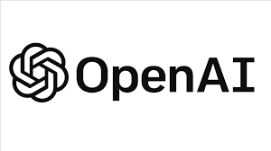**Review about ChatGPT**

**Overview**

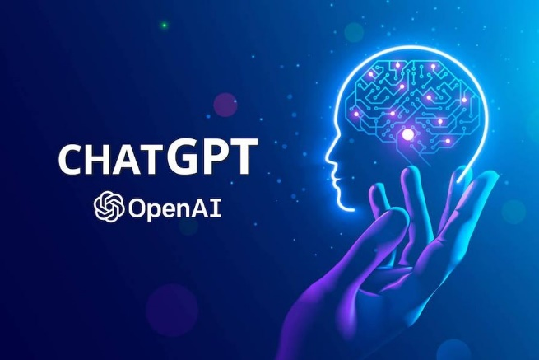ChatGPT is the most well-known AI tool in late 2022. is a fascinating tool with the potential to be helpful in many stages of the software development process. ChatGPT can offer extra viewpoints and help with various activities, from coming up with ideas and requirements to writing code and tests, as an LLM that has "read" billions of web pages can.

Another strength of ChatGPT is its versatility. It can perform a wide range of tasks, from language translation to text summarization and conversation generation. This makes it a valuable tool for a wide range of applications, from customer service chatbots to virtual assistants.

**Features**

1. Language understanding: ChatGPT can understand human languages and generate responses like human

2. Large training dataset: ChatGPT has been trained on a massive dataset of text, allowing it to generate high-quality responses to a wide range of prompts.

3. Large access to database: ChatGPT has big access to large databases that enable it to generate a perfect response to users.

4. Versatility: ChatGPT can perform a wide range of tasks, from language translation to text summarization and conversation generation, making it a valuable asset for a wide range of applications.

**After trying it**

Unfortunately, ChatGPT doesn’t work in Egypt and show this message when anyone from Egypt beginning to create new account “Not available OpenAI's services are not available in your country.”. but most of curious Egyptian that want to try ChatGPT turn on VPN services to try it and I’m one of them. When I use ChatGPT I found it very useful, incredibly it helps me to fix a lot of bugs in my code that I can’t fix on my own. I tested it to generate a function in C++ PL and it was effective and created it exactly as I wanted, and I was surprised by its performance.

However, like all AI models, ChatGPT is not perfect and has some limitations. It may misunderstand the nuances of human language and may provide responses that are insensitive or inappropriate in certain situations. It may also suffer from biases in the data it was trained on.

**Conclusion**

To sum up, ChatGPT is a powerful tool with a wide range of potential uses.

ChatGPT is an impressive tool that has the potential to transform the way we interact with machines. ChatGPT represents a significant advancement in the field of artificial intelligence, and its continued development ChatGPT3 -> ChatGPT4.

However, as with all AI models, it is important to use ChatGPT responsibly and be aware of its limitations. Its ability to generate responses that are insensitive or inappropriate in certain situations can have unintended consequences.

Before using any tool in a certain situation, it is crucial to weigh its potential advantages and disadvantages.